INDIAN INSTITUTE OF TECHNOLOGY PALAKKAD

ID1050A ENGINEERING DESIGN

**Initial Design Document**

October 19, 2023



**Title:** Open Faucet/Running Water Detection System

**Problem Statement:** Running water due to open taps/faucets causes a lot of wastage of water and frustration on the user’s end

**Identification of user need:** I have personally experienced the problem at my home. My mother used to check every tap after we had guests to make sure none of them are open. She sometimes left them open by mistake which led to the tank running dry.  
A recent experience was in Brindavani Hostel. I saw the washbasin tap open in the morning.

**Research conducted:**

* Checking out different methods which can be used to detect small flow of water, which includes [Ultrasonic](https://en.wikipedia.org/wiki/Ultrasonic_flow_meter) and [Electromagnetic](https://en.wikipedia.org/wiki/Magnetic_flow_meter) methods
* Finding out how a faucet works

**Solutions already present:**

* No direct solutions are available for this specific problem.
* Indirectly, there are several technologies which can accurately detect the water flow, which includes [Ultrasonic](https://en.wikipedia.org/wiki/Ultrasonic_flow_meter) and [Electromagnetic](https://en.wikipedia.org/wiki/Magnetic_flow_meter) flow meters.
* The problem can also be solved using automated faucets which turn themselves off after certain time period, like the proximity-triggered faucets, or spring-loaded faucets.
* There are indirect solutions like leakage detector, which lays on the floor and detects presence of water on the floor. [Source](https://www.moen.com/flo)
* Some industry-grade solutions include a thermal imaging camera which detects changes in temperature to detect water leaks. [Source](https://www.indiamart.com/proddetail/thermal-camera-for-water-leaking-leakage-detector-ht-18-21856629888.html)

**Merits:**

* + These systems are quite reliable and proven
  + The electromagnetic system is quite innovative and can detect small amounts of flow of water
  + They often come with a mobile app for ease of operation

**Demerits:**

* + They are more expensive than normal faucets
  + The problem is not resolved 100% using these solutions
  + They may not be practically usable for a common man, e.g., you can’t just replace all the faucets with smart ones in every single house to solve the issue.
  + The ultrasonic sensor can detect small flows only when the pipe is completely full or full till the brim of the sensor, but it can not detect very small water flow.

**Proposed solutions:**

I would prefer my solution to be flexible so it can be attached to many pipe/opening sizes

1. A flexible hydrophobic film can be used as a base and two electrodes can be stuck onto it. This flexible contraption can then be bent into a circular shape and be put inside pipes. The hydrophobic film will be at an angle to remove any excess water from between the electrodes. There may be some water on the electrodes, but none between them, so they are not conducting yet.  
     
   When the water flow is fast enough, the hydrophobic film will be unable to keep the water away from between the electrodes and the circuit will be completed.  
     
   This system will be placed at the end of faucets for ease of installation.  
     
   **Pros:**
2. The system is flexible; hence it can fit into any pipe fixture.
3. The sensor can be connected to any other system which can further send the message to the user via different interfaces.
4. It can be replaced easily.

**Cons:**

1. It doesn’t take into account that the water pipes will be mostly full when no water is flowing, hence giving an *always high* signal, which is not useful.
2. It detects the flow of water by checking its presence against certain conditions, but it may lead to may false positives.

**Sketches:**

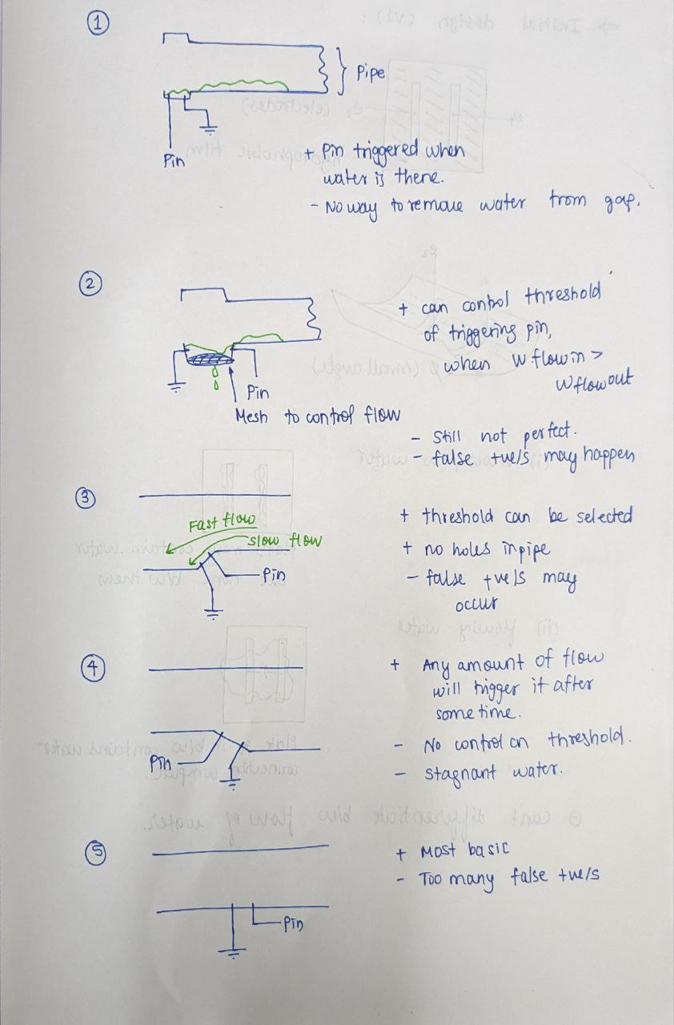

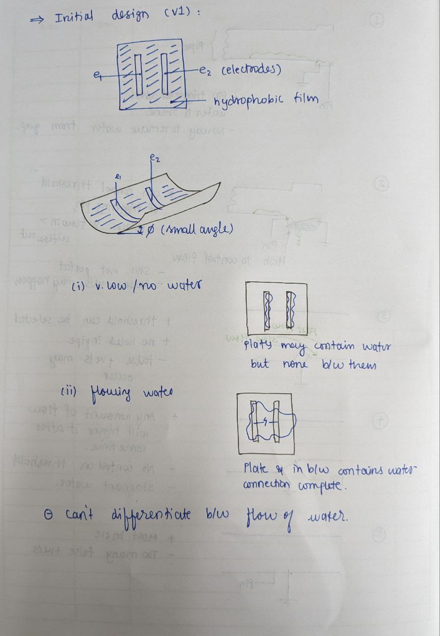

1. A similar flexible hydrophobic film, but this time the electrodes will be of full length of the film, which can wrap across the entire pipe. The system will measure the resistance of water across the electrodes. More water will cause less resistance across the electrodes.  
     
   This improved system will detect the amount of water present at the end of the faucet at any given time and the sensor can be connected to any other systems which can further send the message to the user via different interfaces.

**Pros:**

1. The system is flexible; hence it can fit into any pipe fixture.
2. The sensor can be connected to any other system which can further send the message to the user via different interfaces.
3. It can be replaced easily.
4. It is more reliable than the previously proposed solution and can provide more data with similar amount of electrical and physical components.

**Cons:**

1. Under certain conditions, it may not work as expected due to some assumptions taken during designing of the solution
2. More cons can be found by doing experiments

**Sketches:**

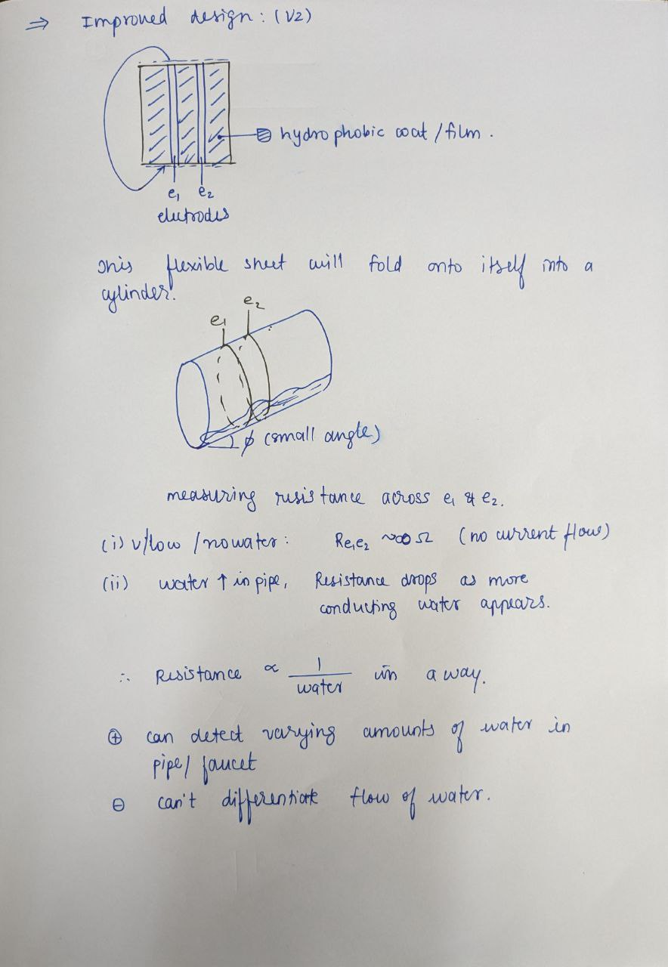

I propose we select the **second solution** for prototyping.

**Dimensions:**

The solution I propose is flexible. Approximately, it will be 3cm ✕ 1cm, but it can be made larger or smaller based on experiments.

**Method of fabrication:**

If needed, we can make a 3D printed enclosure for the electrical components to shield them from water. Alternatively, laser cutting can also be used.

**Bill of materials:**

1. [ATTiiny85](https://robu.in/product/attiny85-20pu-microchip-8-bit-mcu-avr-attiny-family-attiny85-series-microcontrollers-avr-20-mhz-8-kb-8-pins-dip/) for the final project if it is NOT based on Wi-Fi
2. [ESP826-01](https://robu.in/product/esp-01-esp8266-serial-wifi-wireless-transceiver-module/) for the final project if it IS based on Wi-Fi
3. [Arduino UNO](https://store-usa.arduino.cc/products/uno-r4-wifi?selectedStore=us) for prototyping (to be purchased by own money)
4. [LEDs](https://robu.in/product/orange-100pcs-5-colors-f3mm-led-kit/) for prototyping
5. Connection Wires
6. [Hydrophobic Film](https://www.amazon.in/HSR-Accessories-Rainproof-Waterproof-Rectangular/dp/B0C3ZWDSGH/ref=sr_1_4?crid=3S3CQT72F650K&keywords=hydrophobic%2Bfilm&qid=1697732446&sprefix=hydrophobic%2Bfil%2Caps%2C305&sr=8-4&th=1) (ones sold for car mirrors)
7. [Electrodes](https://www.amazon.in/HINDALCO-Freshwrapp-Aluminium-Foil-33g/dp/B012VP2CMK/ref=sr_1_7?keywords=aluminium+foil&qid=1697732537&sr=8-7), preferably Aluminium foil
8. 3D Printed enclosure (if needed)

**Approximate Cost:**

1. ₹230 for ATTiny85
2. ₹105 for ESP826-01
3. ₹100 for LEDs
4. ₹350 for Hydrophobic Film
5. ₹70 for Aluminium Foil
6. ₹2500 for Arduino UNO R4 WiFi

So approximately, ₹1000 to ₹2000 will be used for the project.

**Tests planned:**

We can check the flexible system for different types of faucets and different diameters. We can check different water flow rates to check the range of proper functioning and then can think of changes which can be made to increase the range and increase the accuracy.